**HOME Page**



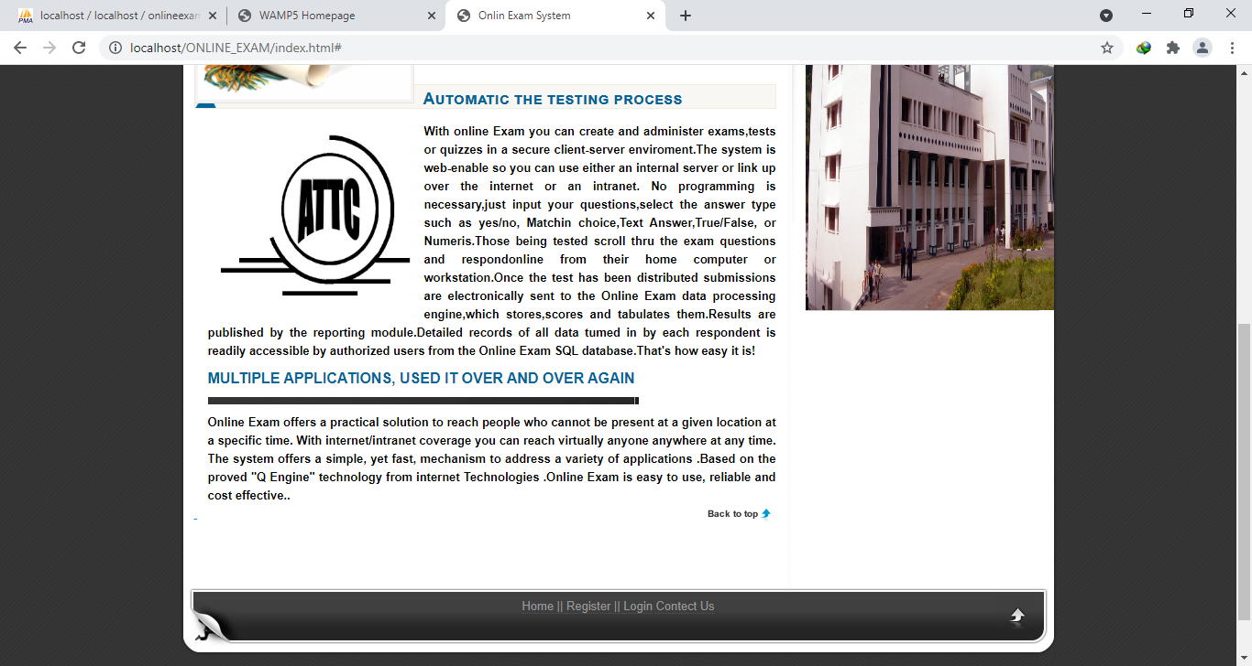

**Registration page**

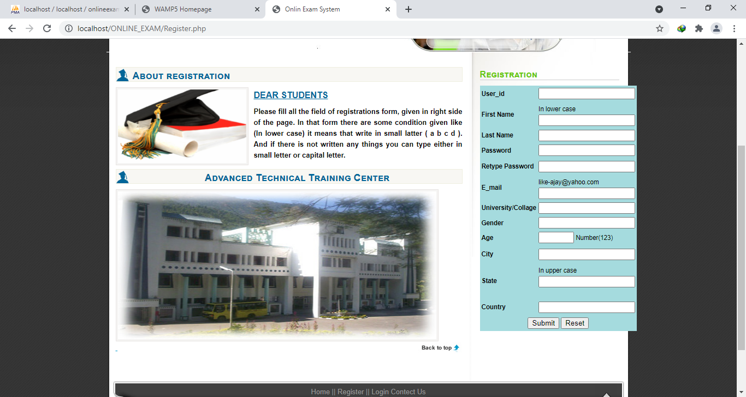

**Login Page**

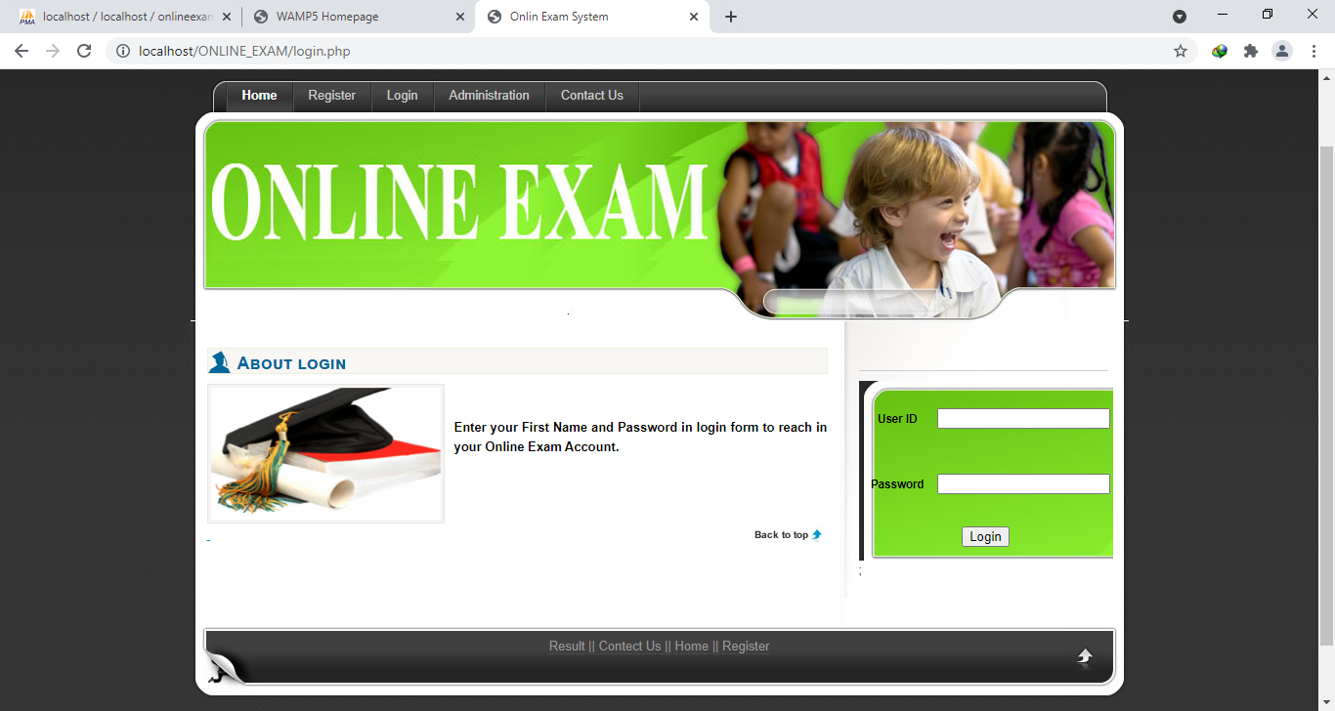

**Administration Page**

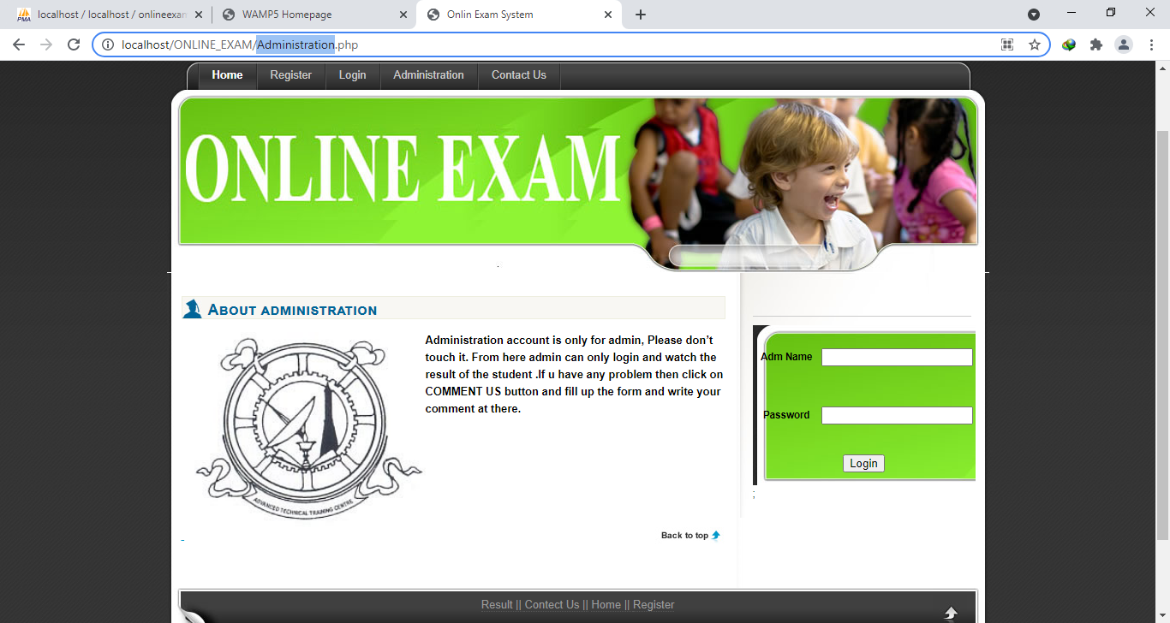

**Contact Us**

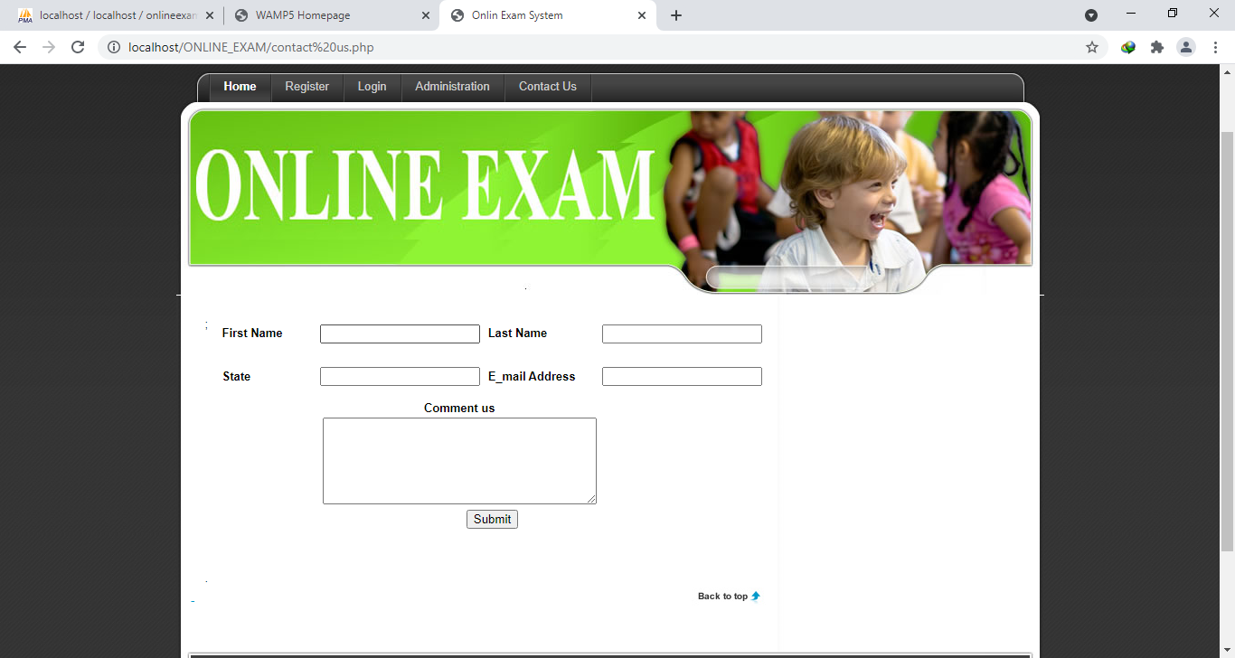

**Register Page Validation**

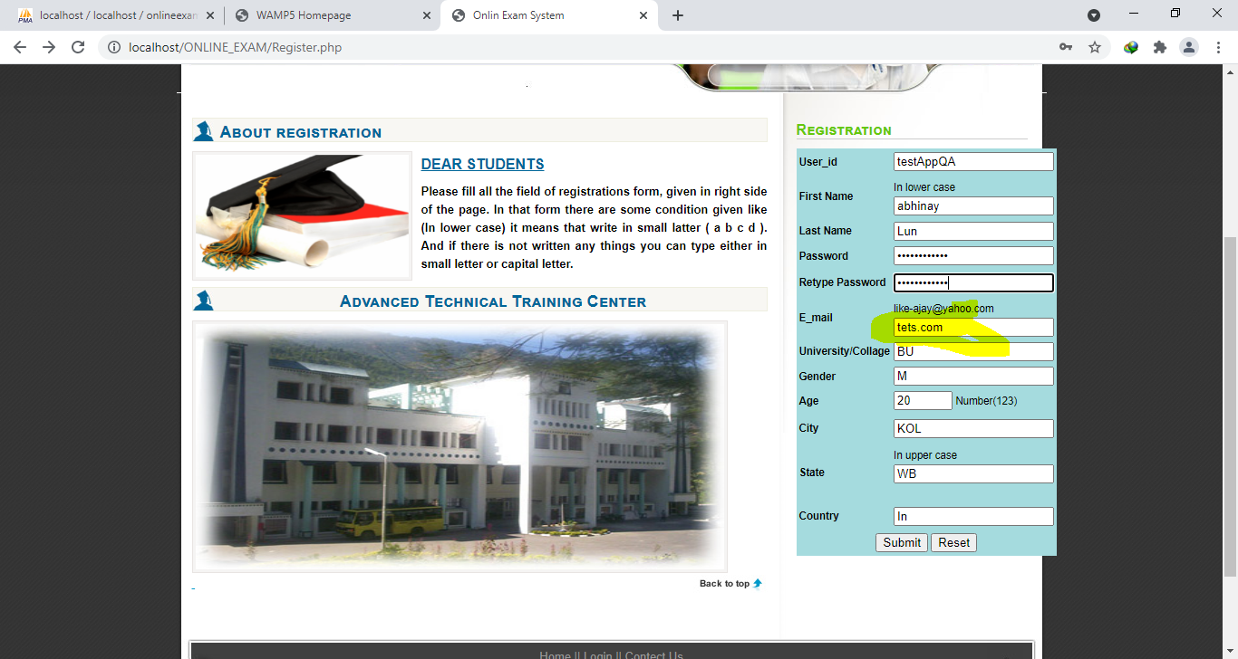

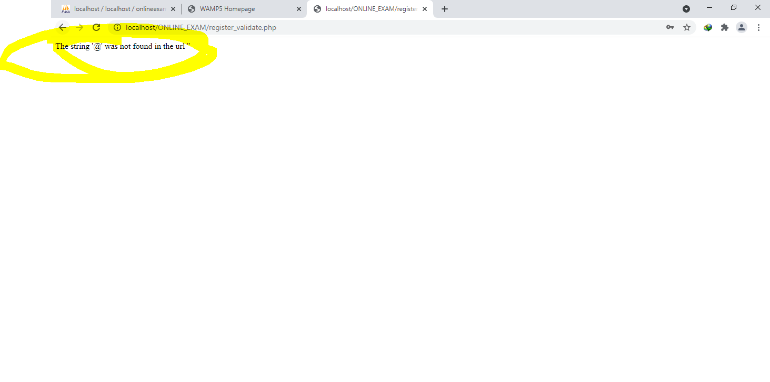

**Register Page Validation**

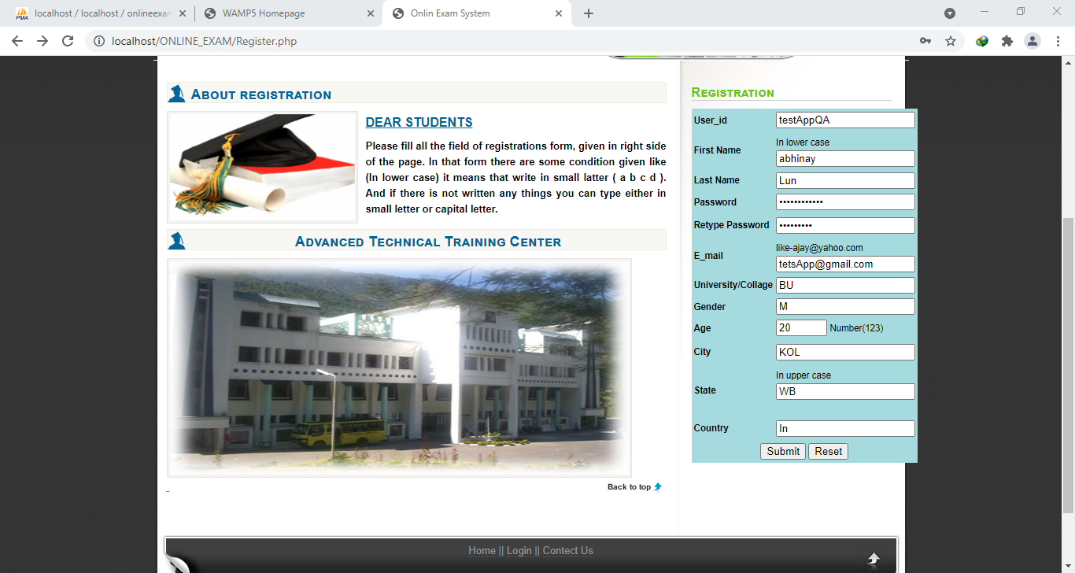

# Valid User loggedIn Welcome to online exam

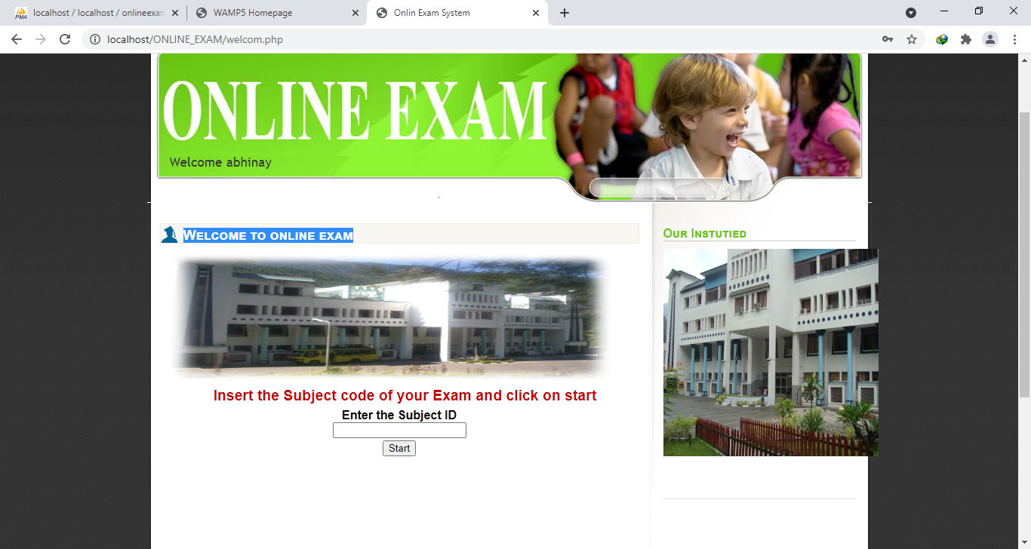

**Invalid User Loggin Page Validation(User Not exist in DB or not registered with System)**

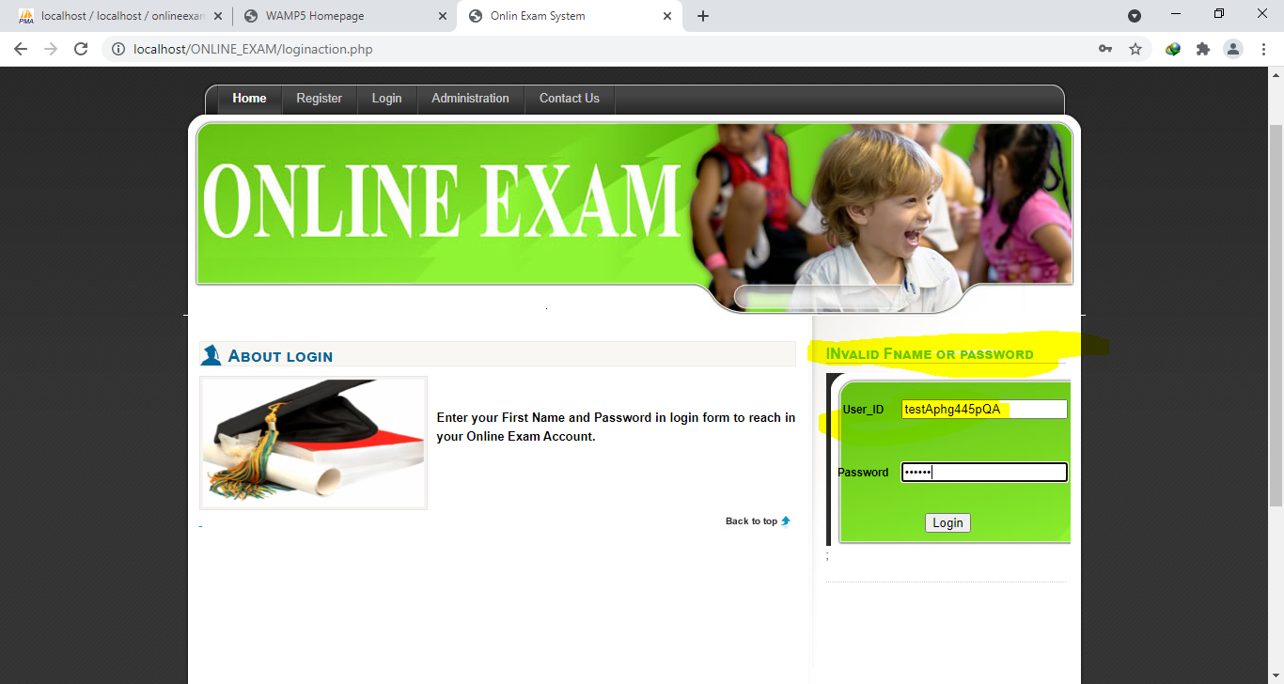

**Invalid Subject ID passed to Welcome page**

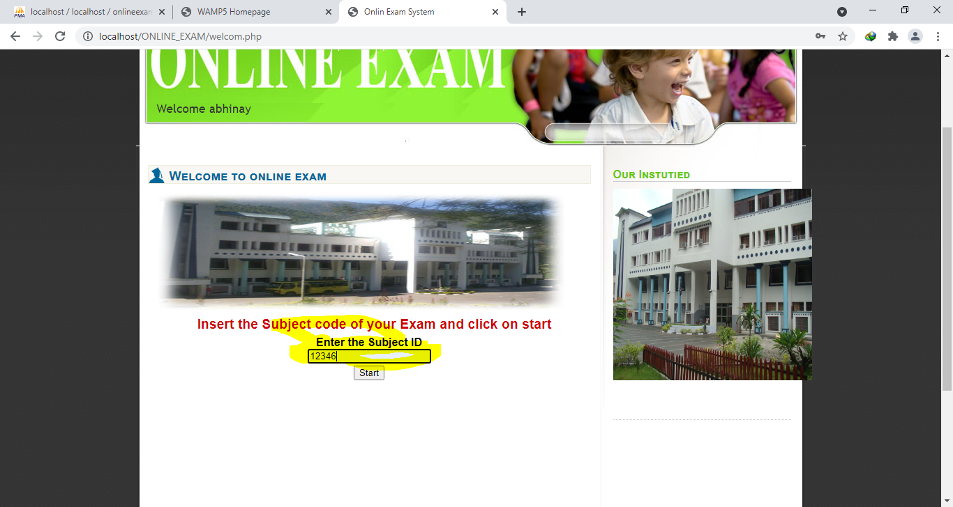

**Subject Id not found**

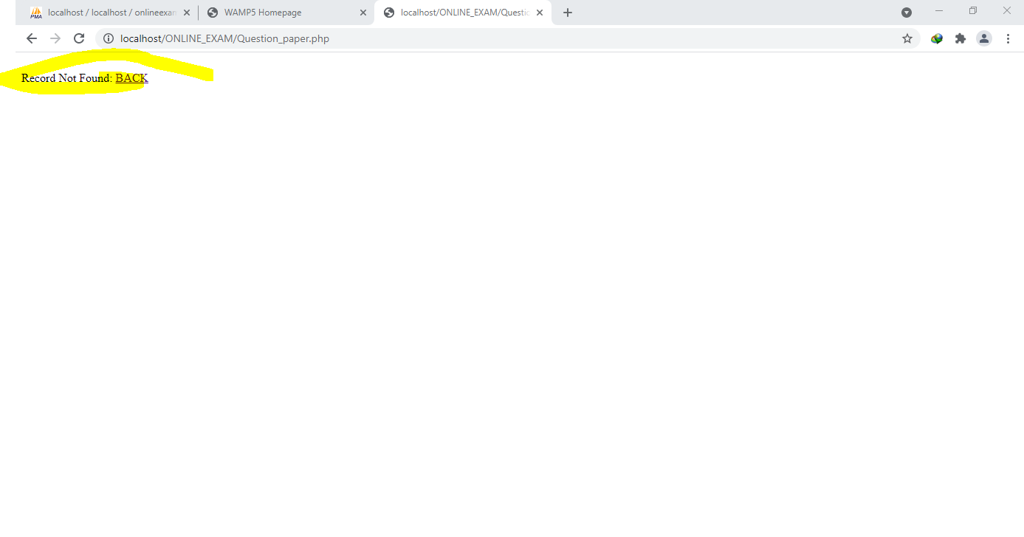

**Valid Subject Id Search**

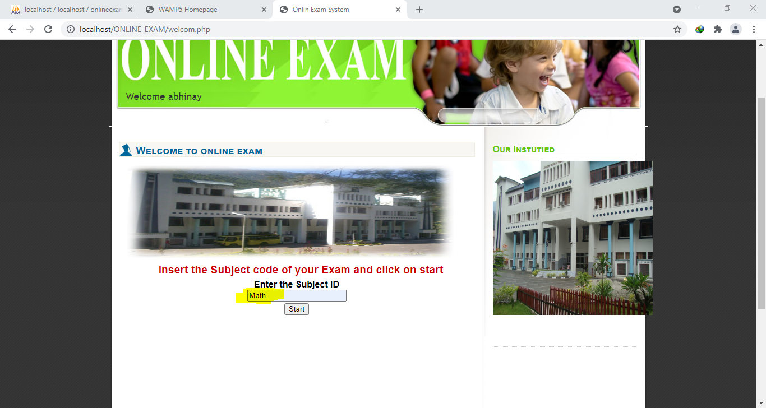

**Examination Page**

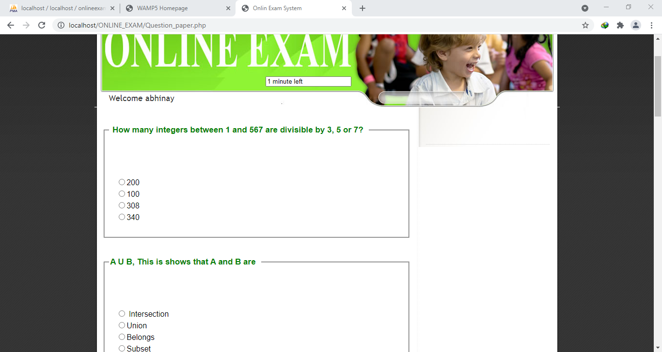

**Exam TimeOut , Result And Logout Page**

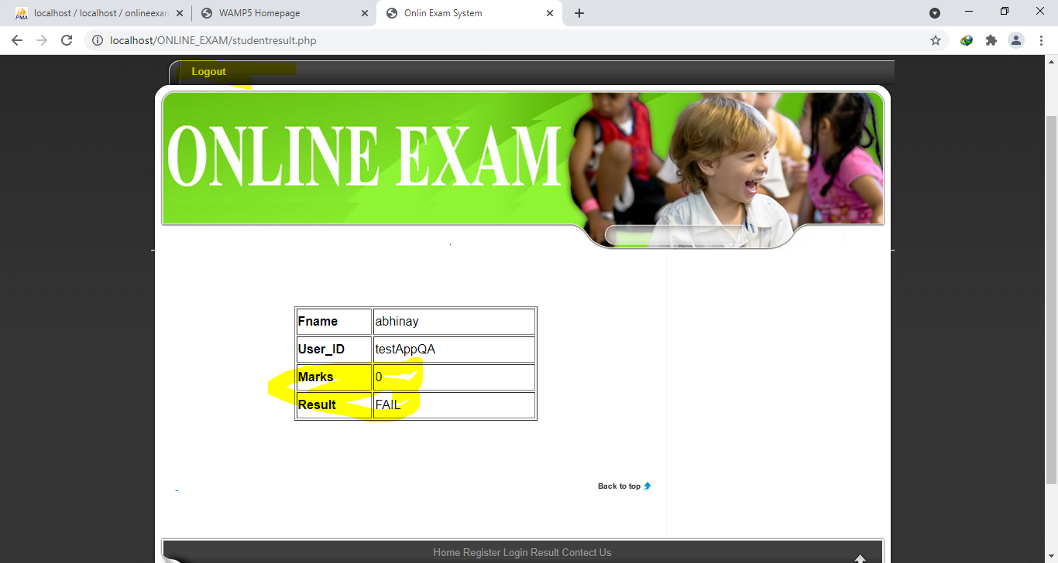

**Contact Us**

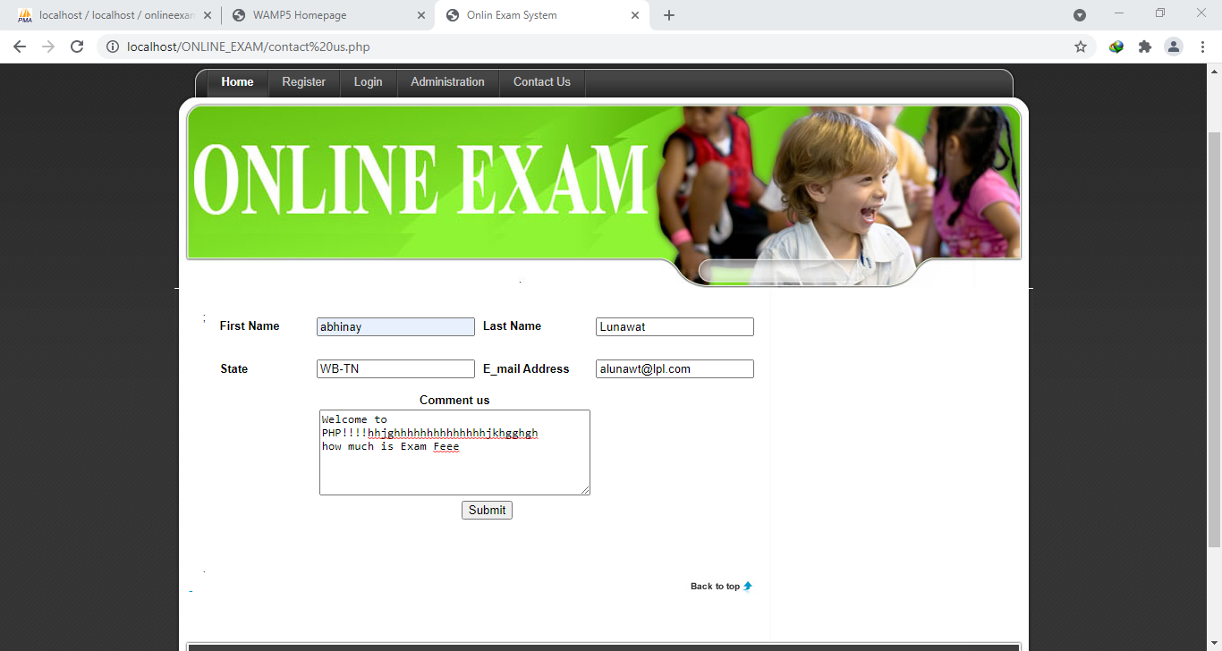

**Contact Us Submission Response**

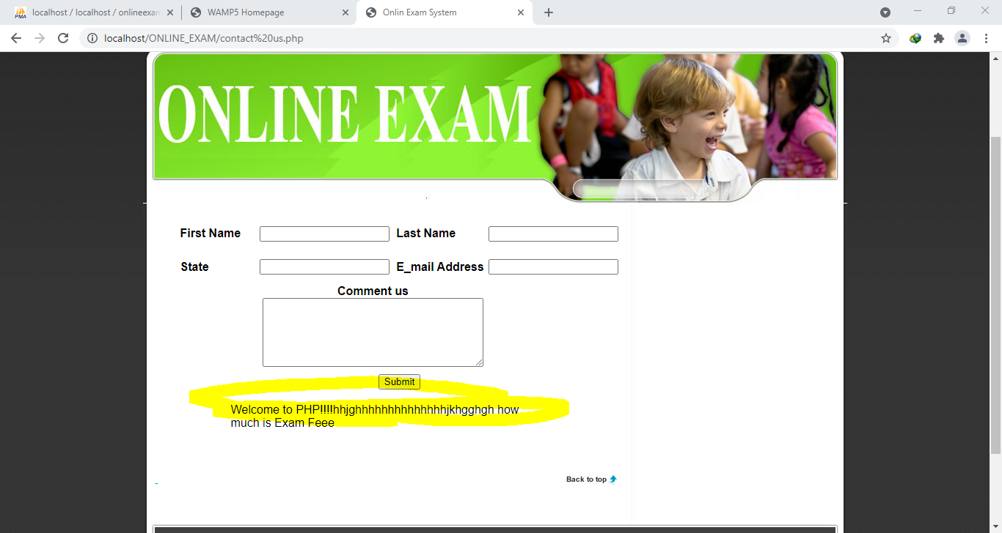

# Invalid Admin Login Attempt From About administration

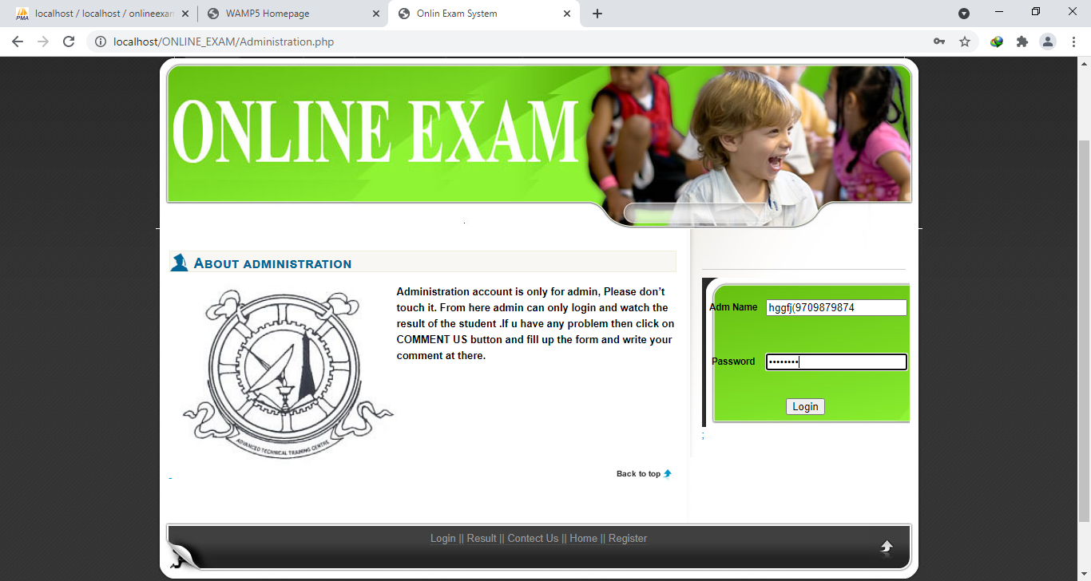

**Invalid Admin Login Attempt Response**

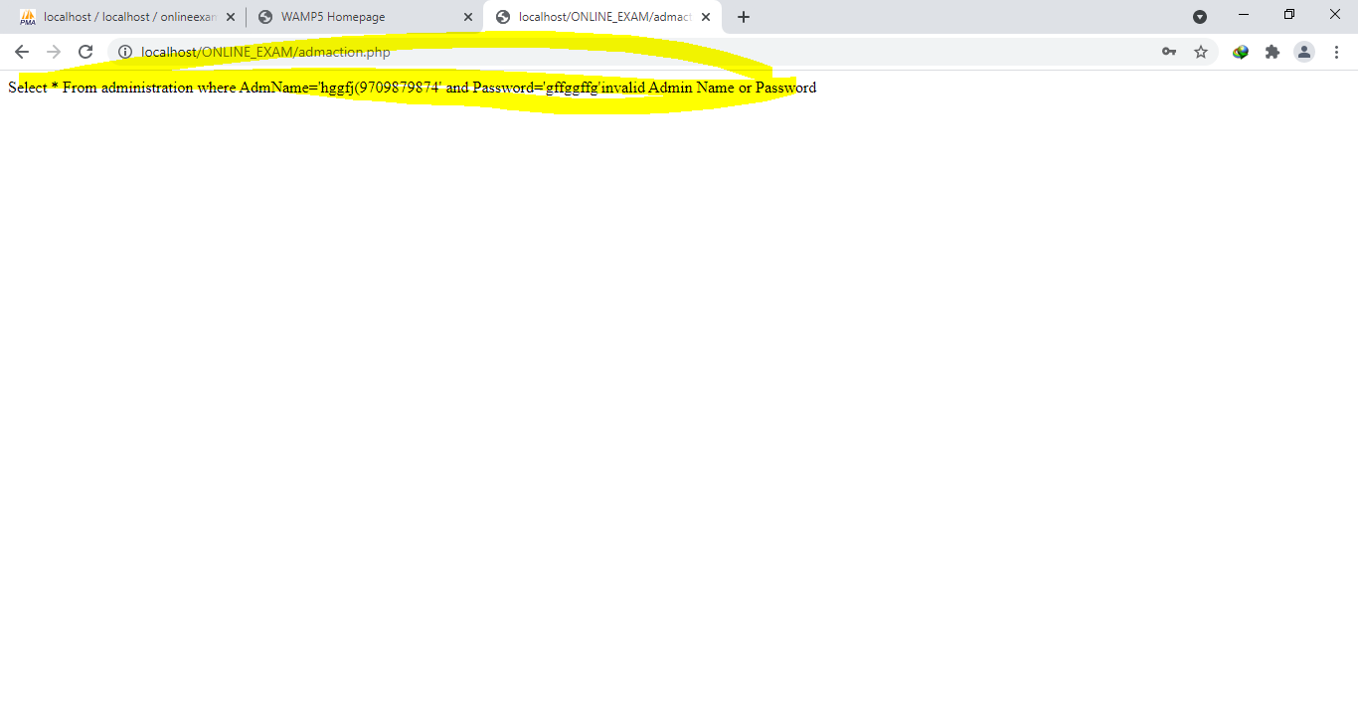

**Valid Admin Users Credentials (Php MyAdmin DataBase)**

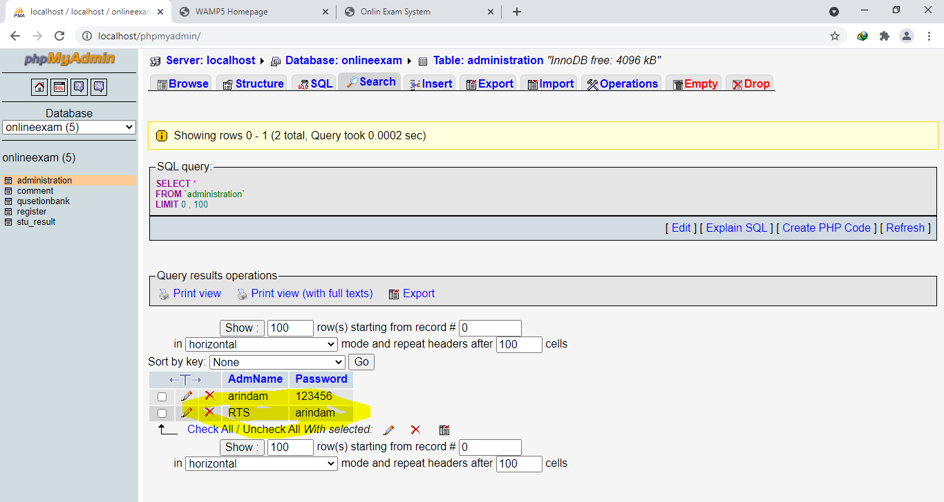

**Valid Admin Users Login Success Home page**

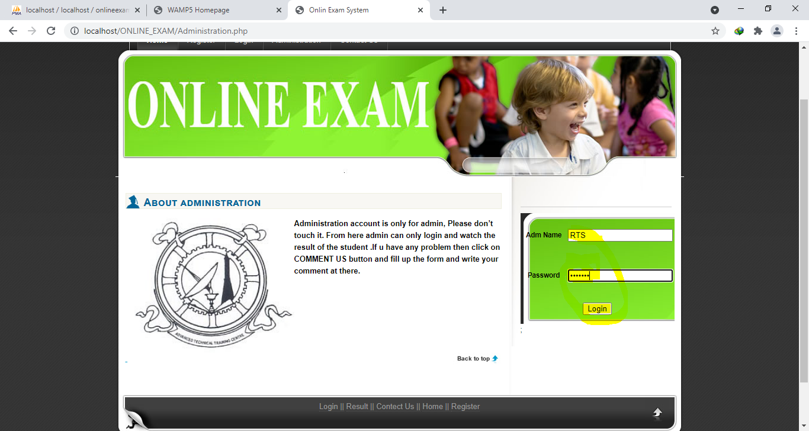

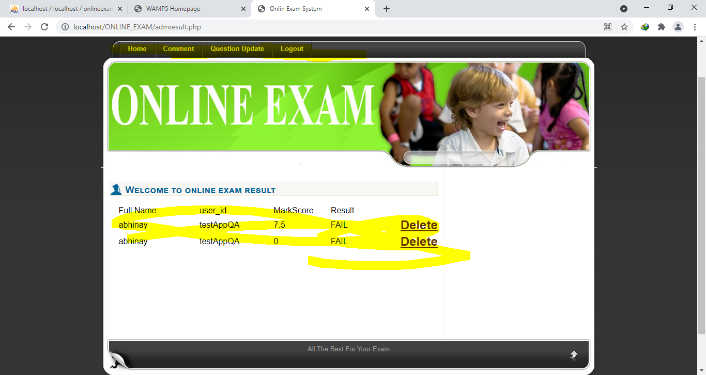

**Admin’s Comment Page**

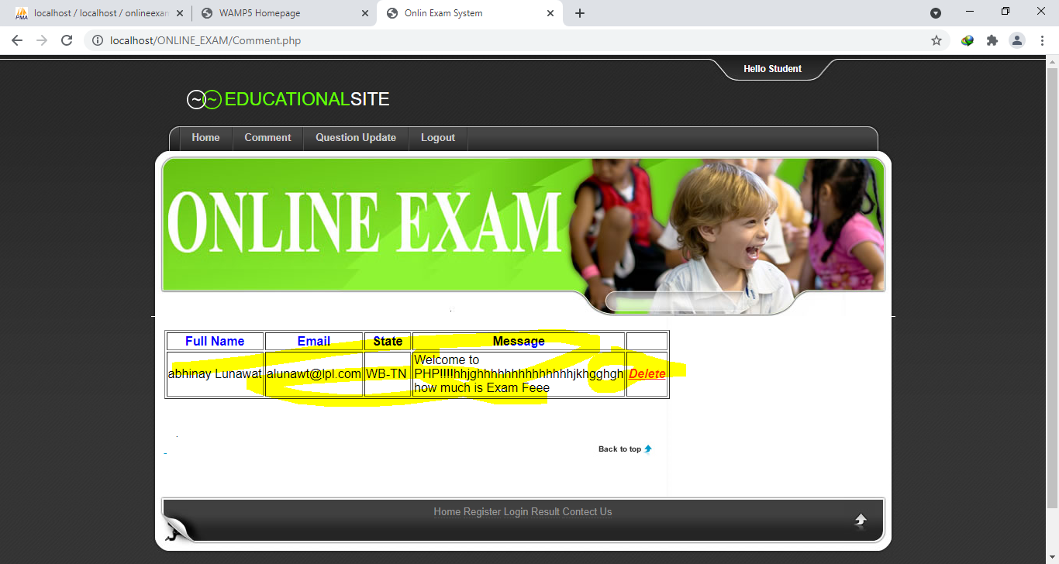

**Online Examination System - Admin's Question and Answer management**

**Admins Question Update Page**

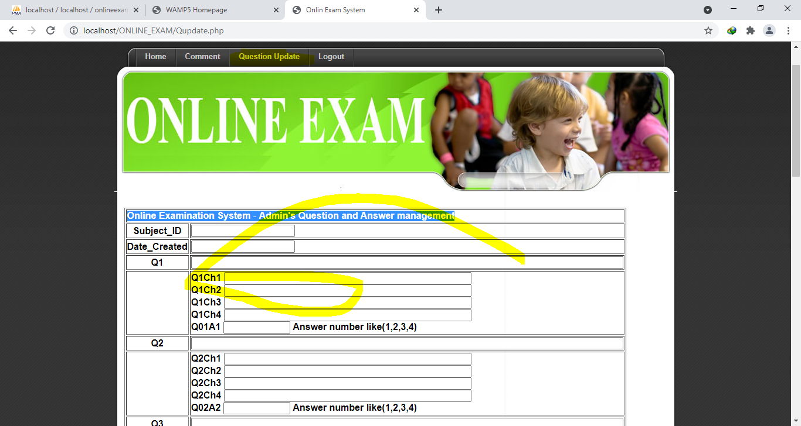

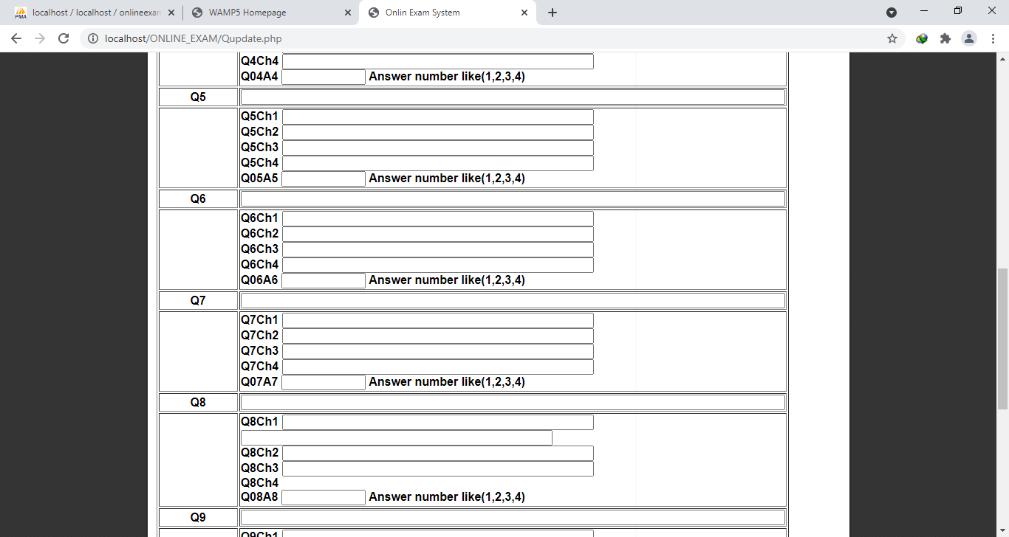

**PHP MyAdmin DataBase Schema Design for System**

**DataBase Name -** [**onlineexam (5)**](http://localhost/phpmyadmin/db_structure.php?db=onlineexam&token=d9b46ba28c2382a8cf4b200838025d3a) **composed of 5 Tables**

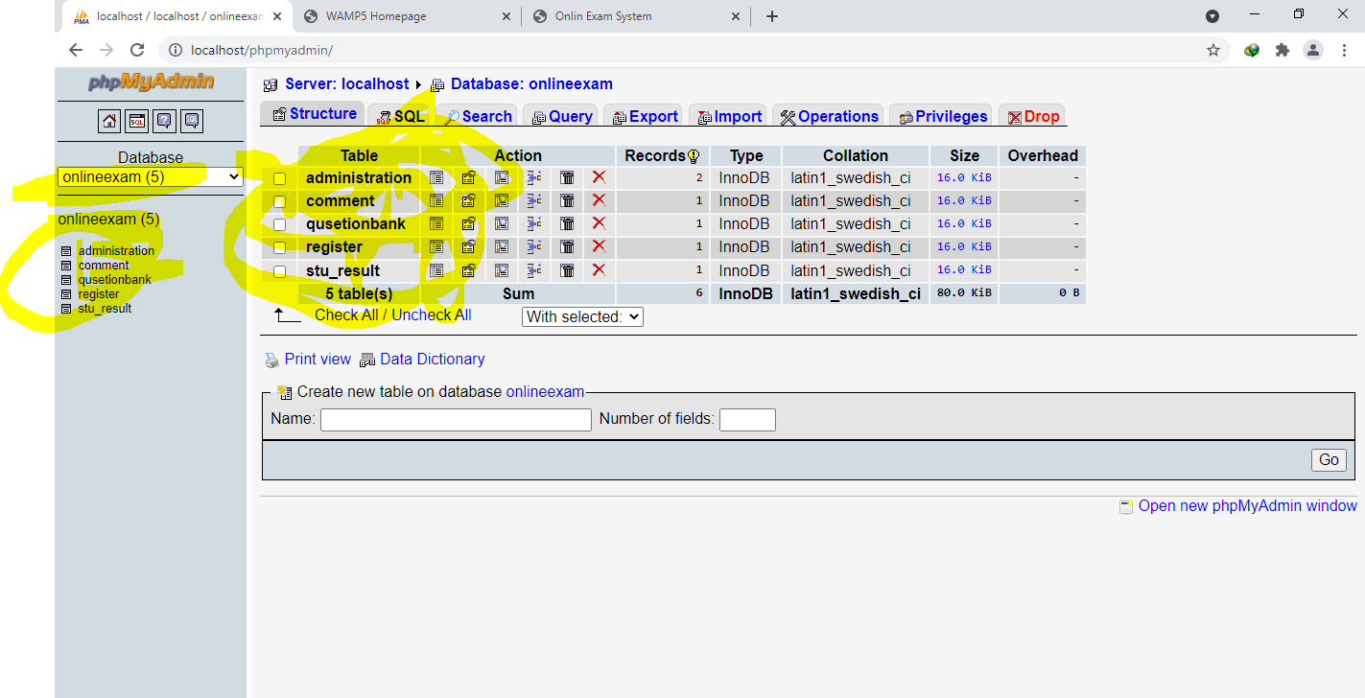

**Administration Table Structure–**

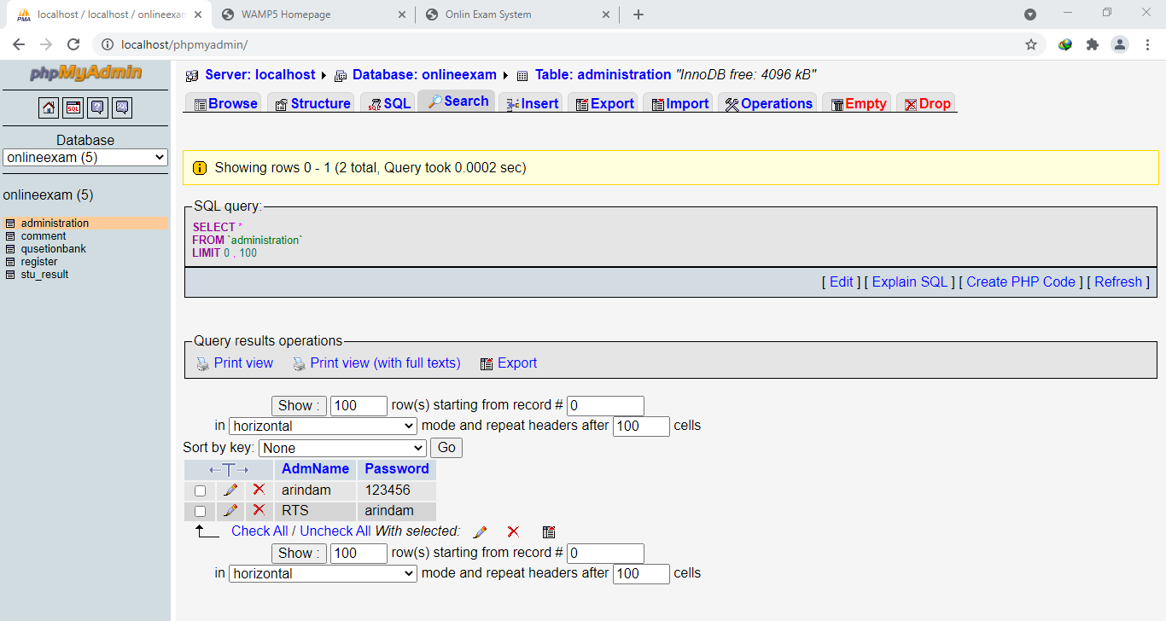

**Comments Table Structure :**

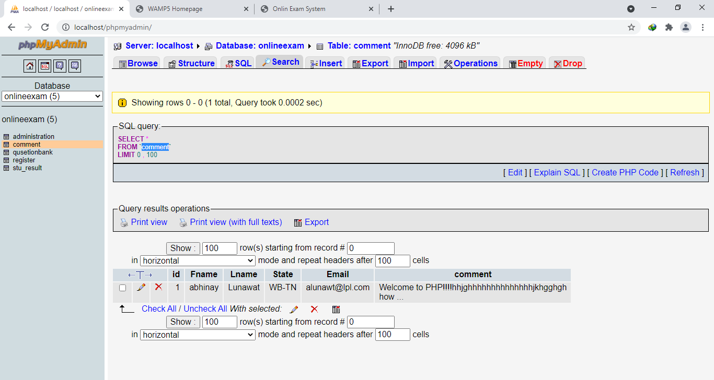

**Qusetionbank Table Structure:**

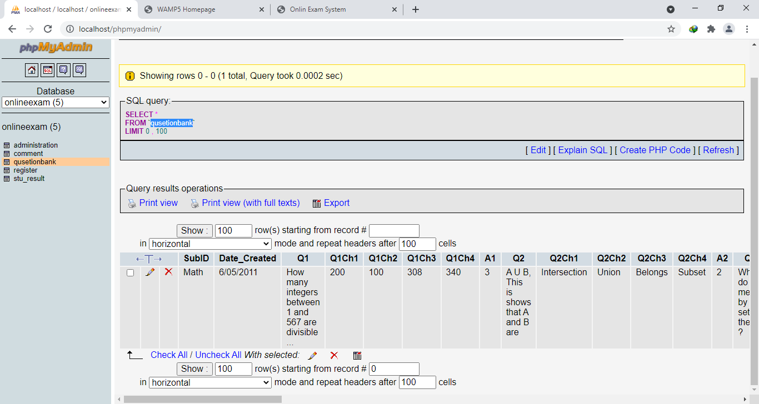

**register Table Structure:**

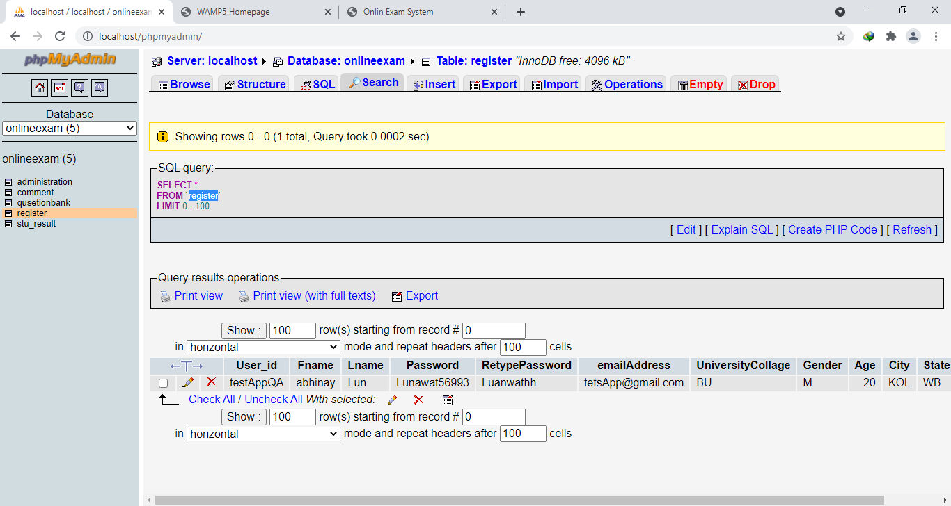

**stu_result Table Structure:**

